
dOP361
GITHUB COLLABORATION REPORT

June 1, 2026
ANGIE MKHONTO
602066

Table of Contents
DEVOPS PRACTICAL ASSIGNMENT – TOOLCHAIN SETUP & INTEGRATION 2
PART A: SETUP & INTEGRATION WORKFLOW 2
Ubuntu Setup 2
Docker Installation and Configuration 4
GIT 5
Chef Installation 6
DOCKER PRACTICAL 7
PART B 7
GITHUB & COLLABORATION 7

DEVOPS PRACTICAL ASSIGNMENT – TOOLCHAIN SETUP & INTEGRATION

My role in the project was Member 5 GitHub & Collaboration, where I was responsible for managing the GitHub repository, integrating all group contributions, handling project files and merging, and ensuring that all project components were correctly structured.

PART A: SETUP & INTEGRATION WORKFLOW
The environment was set up on an Ubuntu 24.04 LTS virtual machine. The required DevOps tools were installed and configured, including Docker, Git, and Chef.

Ubuntu Setup
The Ubuntu system was verified and updated successfully to ensure all required packages were up to date. The system served as the base environment for all DevOps operations.
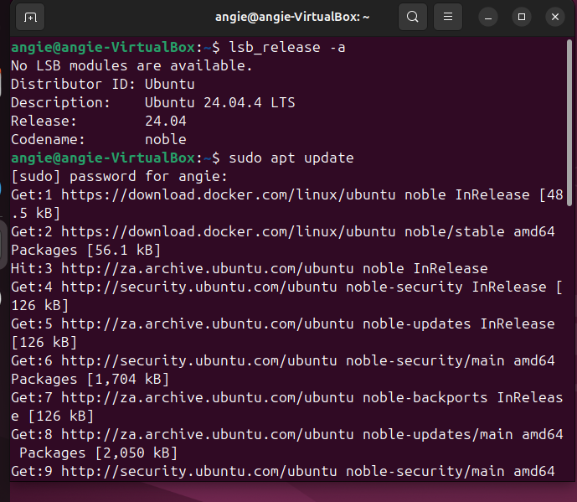
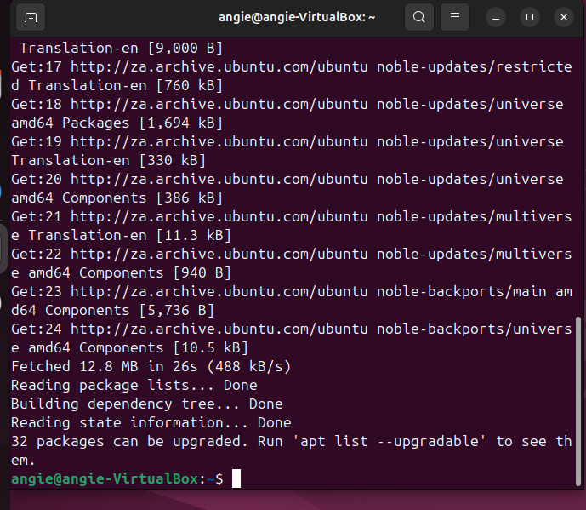

Docker Installation and Configuration
Docker was installed on the Ubuntu system and verified using version checks. A test container was executed successfully using the hello world image, confirming that Docker was functioning correctly.
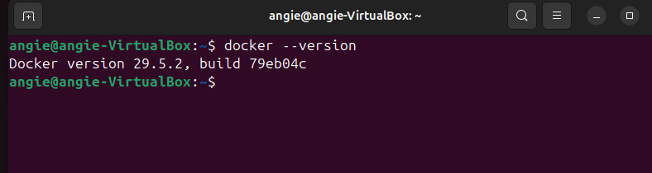
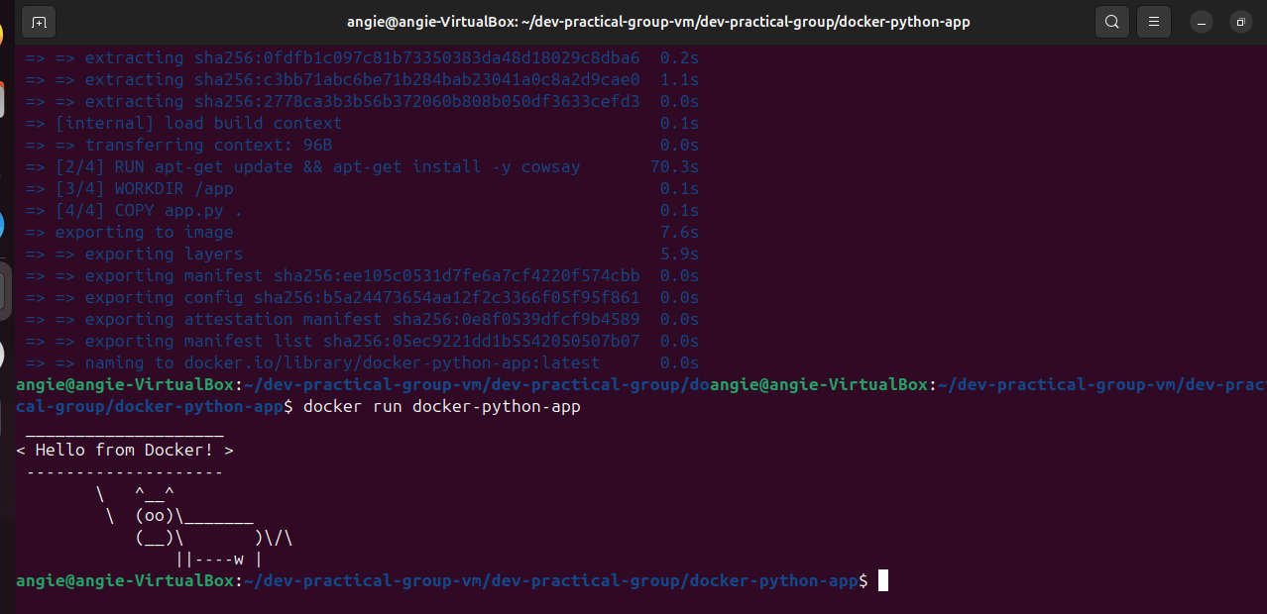

GIT
Git was used for version control and collaboration throughout the project. A GitHub repository was created and cloned locally.
All project files were added, committed, and pushed to the remote repository. Branching was also used to simulate collaboration between team members.
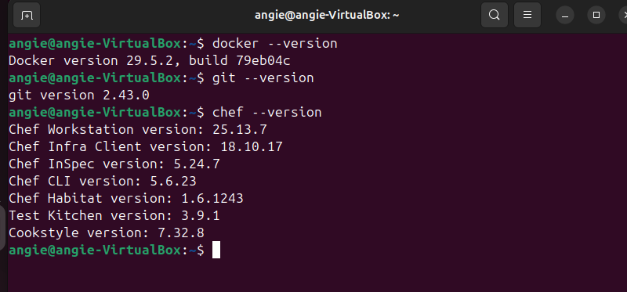

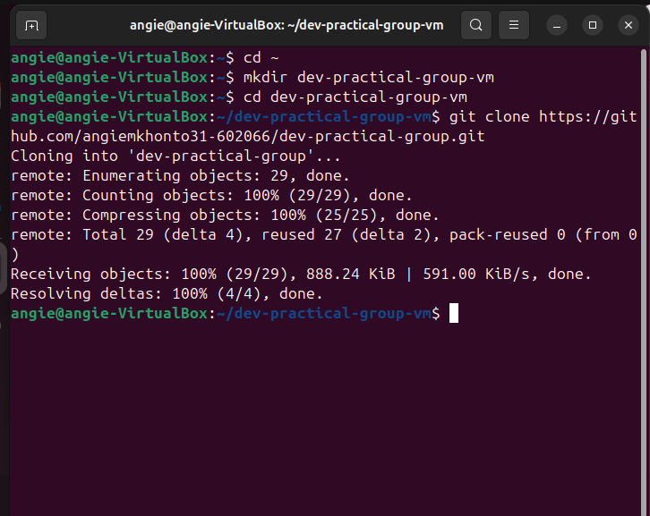

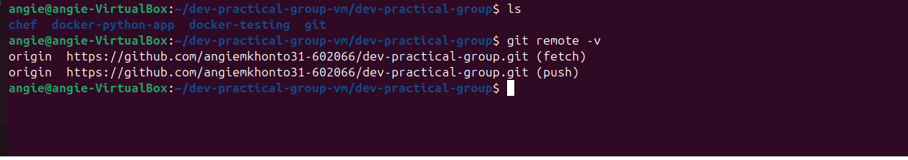

Chef Installation
Chef Infra Client was installed successfully on the system. It was used to create and execute automation scripts for configuration management.


DOCKER PRACTICAL
The Docker image was built using the Docker build command and executed successfully in a container. The output confirmed that the application was running correctly inside the container.
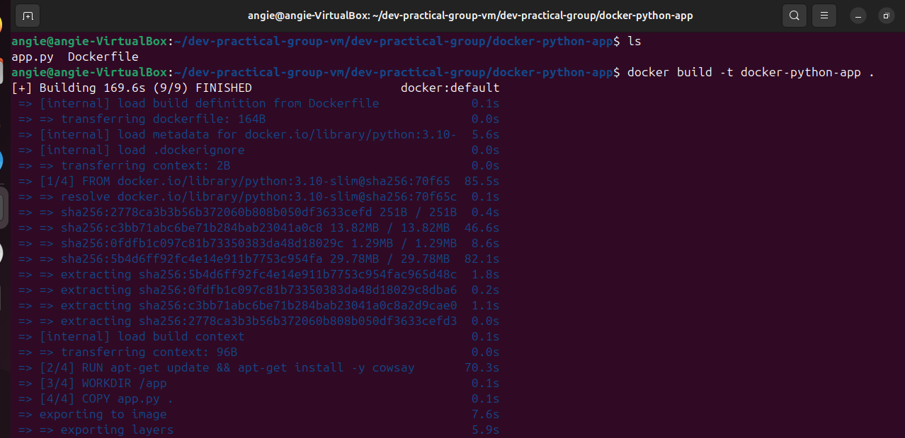

PART B

GITHUB & COLLABORATION

A GitHub repository was created call dev-practical-group, and was shared with group members to push their files, for collaboration.
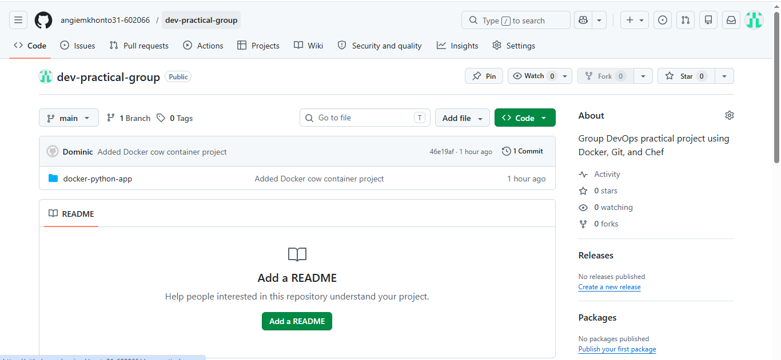
Collaborators invite was sent to group members, allowing them to contribute to the repository which supports the collaborative development.
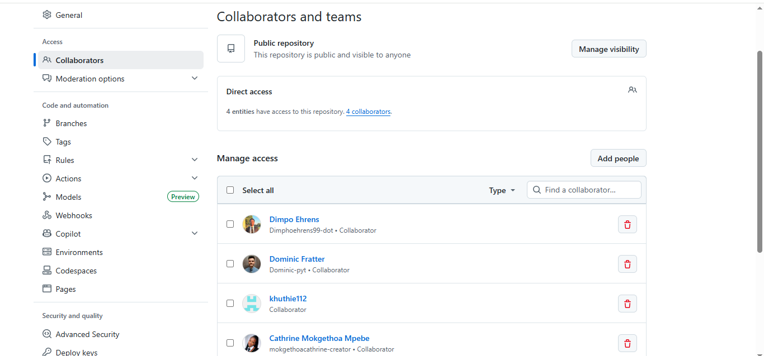

The GitHub repository was cloned using Git Bash
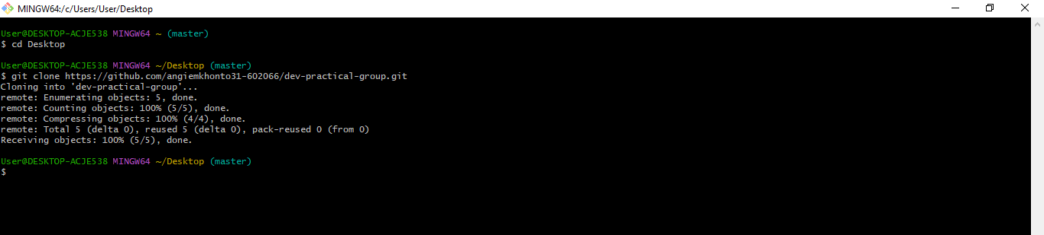
Management of the folders received from member can be seen using the ls command.
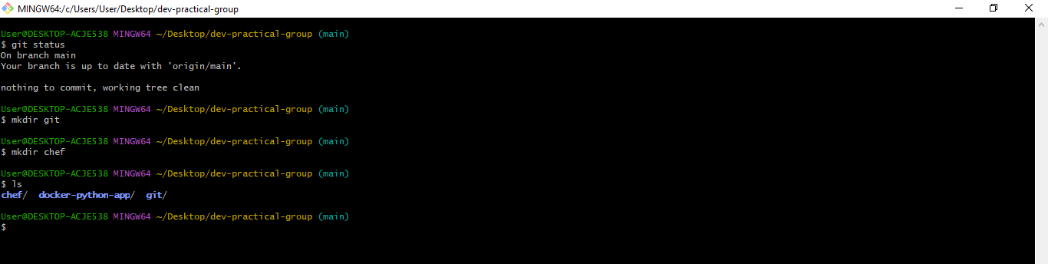

A branch named Dimpo was created by a team member for Git related tasks. This branch was reviewed, fetched, and successfully merged into the main branch to ensure proper integration of all contributions.

The branch on GitHub
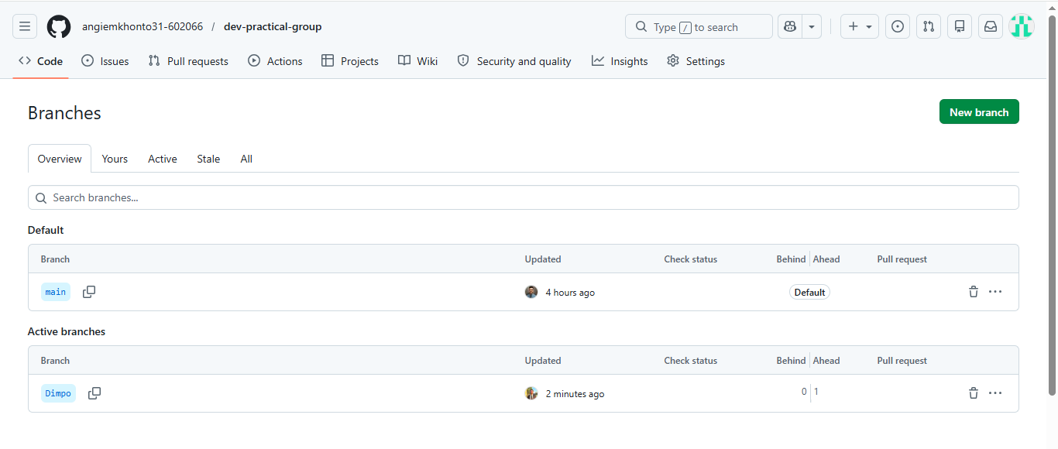
Fetching updates from collaborators
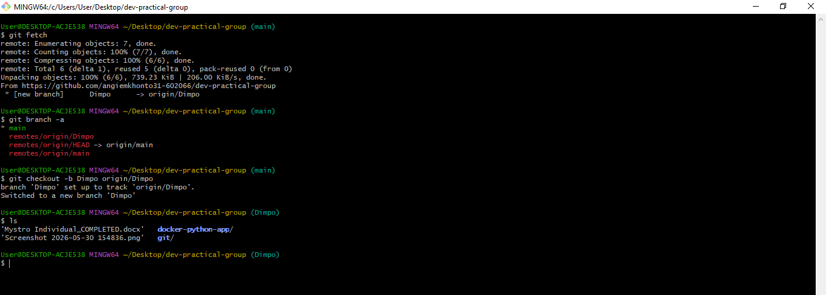
Merging the branch Dimpo to the main and committing.
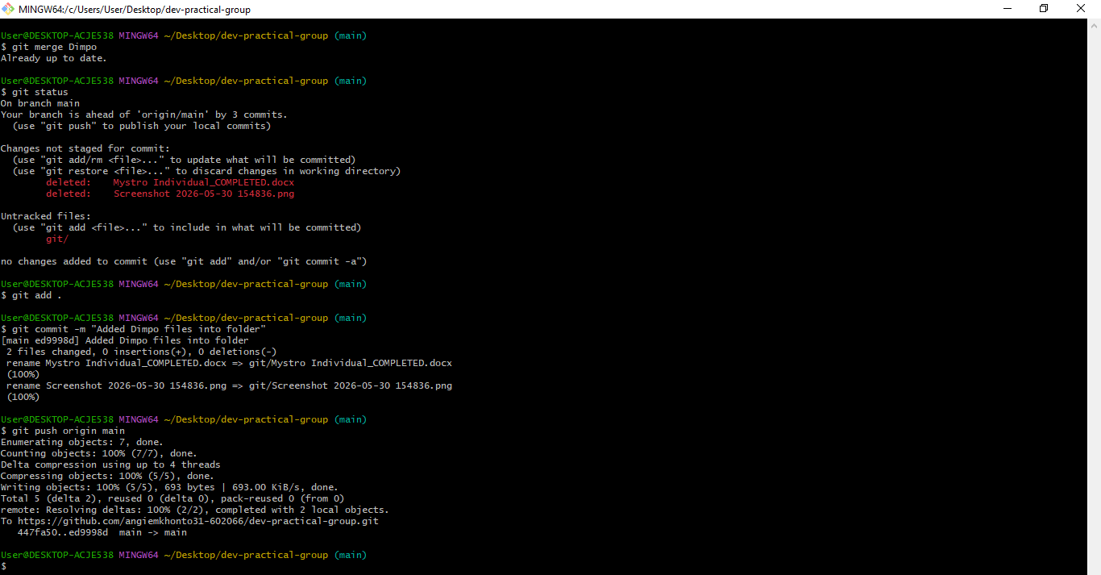
Files from group members who pushed into the repository
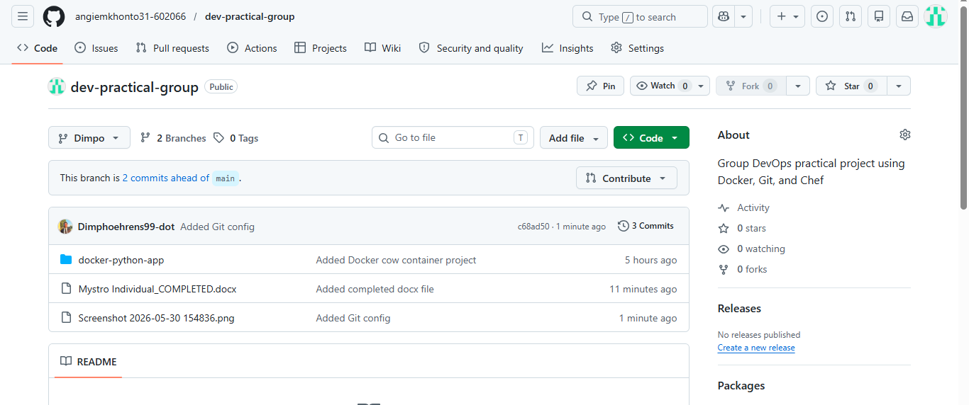
Commiting and pushing changes

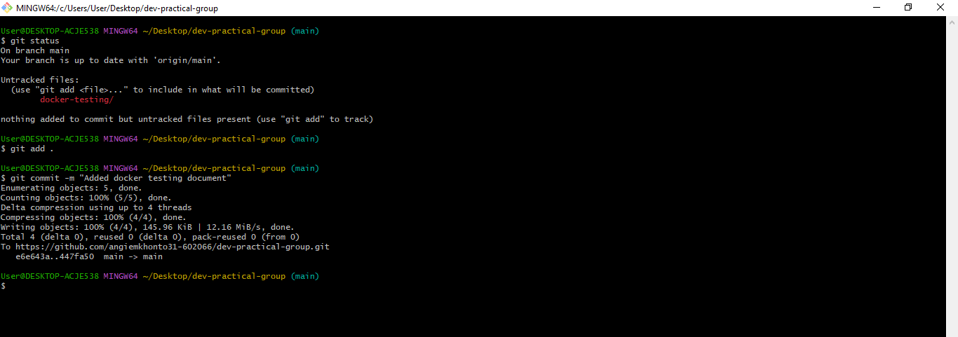
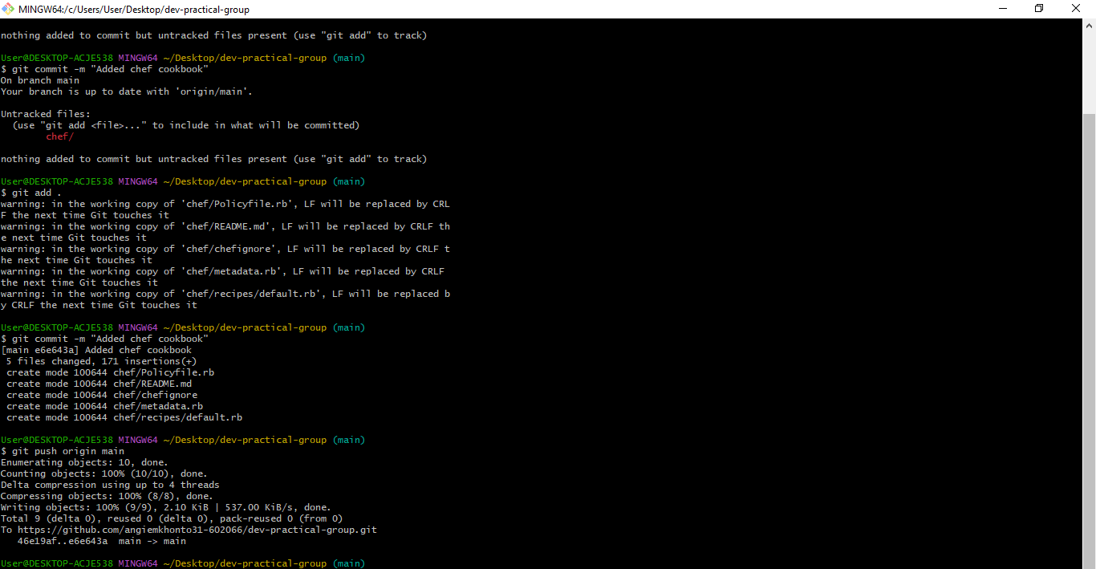
Project files in the group repository
